[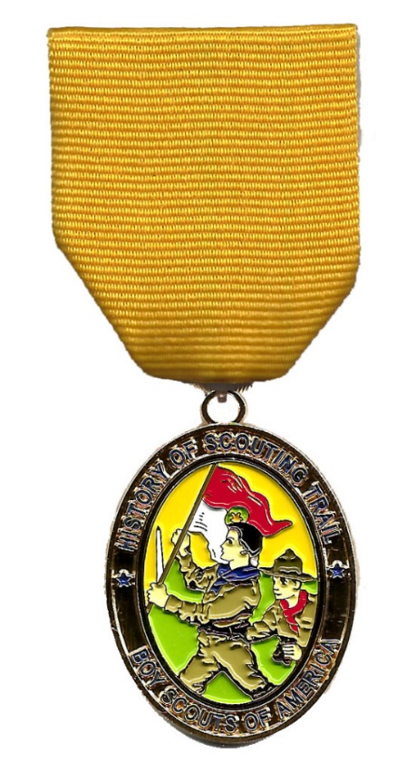](http://www.ncacbsa.org/wp-content/uploads/2015/12/history-hike-medal.jpg)**History Hike**

This 2.5 mile hike takes most units 1–2 hours to complete and the route takes you from the National Geographic Museum and through the area around the White House.

The hike medal, and hike patches, will be available for purchase after being successfully earned by completing 85% or more of the activities associated with the hike. You will have the opportunity to redo activities if needed, in order to qualify you for your medal.  When you complete the HOST hikes, you can purchase the patches and medals at any of the partner museums, at the Marriott Scout Service Center in Bethesda, or over the phone.

**Where does it start?**

The History Hike starts in the courtyard of the National Geographic Building near 15th and M Street.

**Where does it end?**

The Hike ends at one of several partner museums who will collect your answer sheets and sell awards and souvenirs in their gift shops. All endpoints are near Metro Center Metro station and also only a short walk to Gallery Place China Town station and Archives Navy Memorial stations for easy access to every color Metro line. You will be told where your end point is at check-in.

**What to bring on the hike?**

Each hiker (including adults) should have:

1. Two pencils or pens
2. A camera (each hiker must be able to take 6 photos individually, sharing is okay, cell phones with cameras are fine)
3. Full Uniform (if you have one)
4. A watch (any kind)
5. One empty plastic bag (supermarket type)
6. Appropriate weather gear and water bottle
7. Sunscreen
8. Curiosity and sense of adventure
9. Money to purchase Hike items at completion

You’ll need at least one of these for the whole group:

1. Compass
2. Small magnifying glass
3. One crisp $10 bill (for one of the clues – you keep it)
4. Binoculars (Recommended)